1. Add Two Numbers

You are given two non-empty linked lists representing two non-negative integers. The digits are stored in reverse order, and each of their nodes contains a single digit. Add the two numbers and return the sum as a linked list.

You may assume the two numbers do not contain any leading zero, except the number 0 itself.

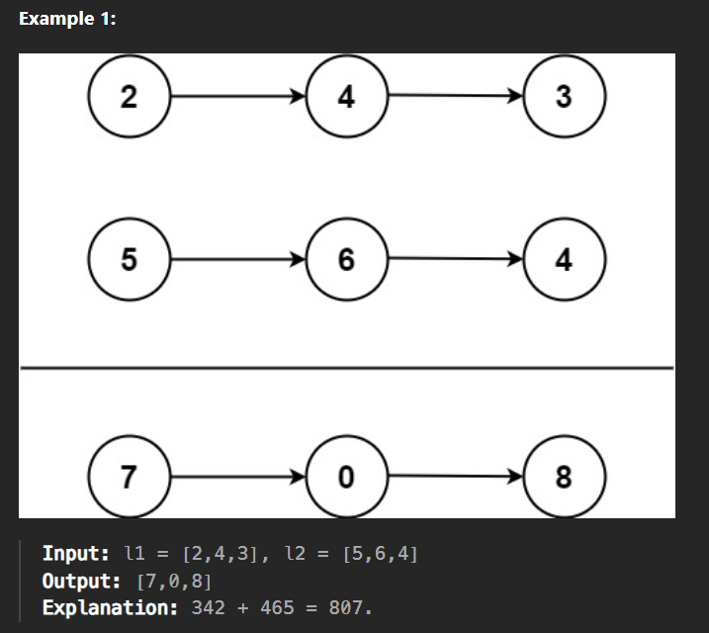

Example 2:

Input: l1 = [0], l2 = [0]

Output: [0]

Example 3:

Input: l1 = [9,9,9,9,9,9,9], l2 = [9,9,9,9]

Output: [8,9,9,9,0,0,0,1]

Constraints:

The number of nodes in each linked list is in the range [1, 100].

0 <= Node.val <= 9

It is guaranteed that the list represents a number that does not have leading zeros.